

**Simulation & Modeling Lab**

**CSE 414**

**Project Report on**

**Smart Traffic Light Simulation for Multi-Lane Intersections**

**Submitted To:**

**Ms. Sonia Afroz**

Lecturer, Department of CSE

University of Information Technology & Sciences

**Saima Siddique Tashfia**

Lecturer, Department of CSE

University of Information Technology & Sciences

#### **Submitted By:**

1. Israt Jahan Eva(7B1_57)

2. Irin Sultana Poly(7B2_91)

3. Sadia Akter(7B1_59_)

4. Asadur Rahman Asif(7B2_79)

**Date of Submission:** 08/12/24

**Introduction:**

The "Smart Traffic Light Simulation for Multi-Lane Intersections" project aims to design an intelligent system that manages traffic lights for multi-lane intersections efficiently. This project simulates a real-world traffic scenario using MATLAB to visualize the functioning of smart traffic lights. The simulation handles dynamic traffic flow and timing for green, yellow, and red signals, ensuring smooth and systematic traffic movement. By utilizing this simulation, we can study the behavior of traffic lights in a controlled environment and analyze potential enhancements for real-life applications.

**Objectives:**

The objectives of this project are as follows:

1. **Efficient Traffic Management:** To simulate a system that optimizes traffic flow by implementing a dynamic timing mechanism for traffic lights.
2. **Visualization of Traffic Scenarios:** To provide a clear graphical representation of traffic movements at a multi-lane intersection.
3. **Dynamic Signal Timing:** To manage timing for green, yellow, and red lights for different lanes and directions.
4. **User-Friendly Interface:** To ensure that the simulation is easy to understand and analyze.
5. **Traffic Analysis:** To observe the performance of traffic management in a simulated environment.

**Methodology:**

The methodology for the "Smart Traffic Light Simulation for Multi-Lane Intersections" project can be summarized as follows:

**1. Setup and Initialization:**

* The project initializes with a defined simulation time and cycle duration for the traffic lights.
* The MATLAB environment is configured to visualize the intersection and traffic lights using graphical elements such as rectangles, circles, and text annotations.

**2. Intersection Layout Design:**

* The intersection is represented graphically with lanes and traffic light positions.
* Traffic lights for all four directions (North, South, East, and West) are assigned positions and colors to indicate their state (red, yellow, or green).

**3. Traffic Light Timing:**

* Each traffic light has a pre-defined green, yellow, and red cycle duration.
* The system cycles through phases to allow smooth traffic flow in specific directions.

**4. Dynamic Visualization:**

* The simulation uses MATLAB’s graphical functions to update traffic light colors and highlight active directions during each phase.
* Active lights are visually emphasized, and divider lines guide lane positions.

**5. Simulation Execution:**

* The simulation runs in a loop, updating the state of each traffic light and the corresponding visualization based on the elapsed time.
* The simulation pauses briefly at each iteration to mimic real-time traffic behavior.

**Implementation:**

**Code Screenshot:**

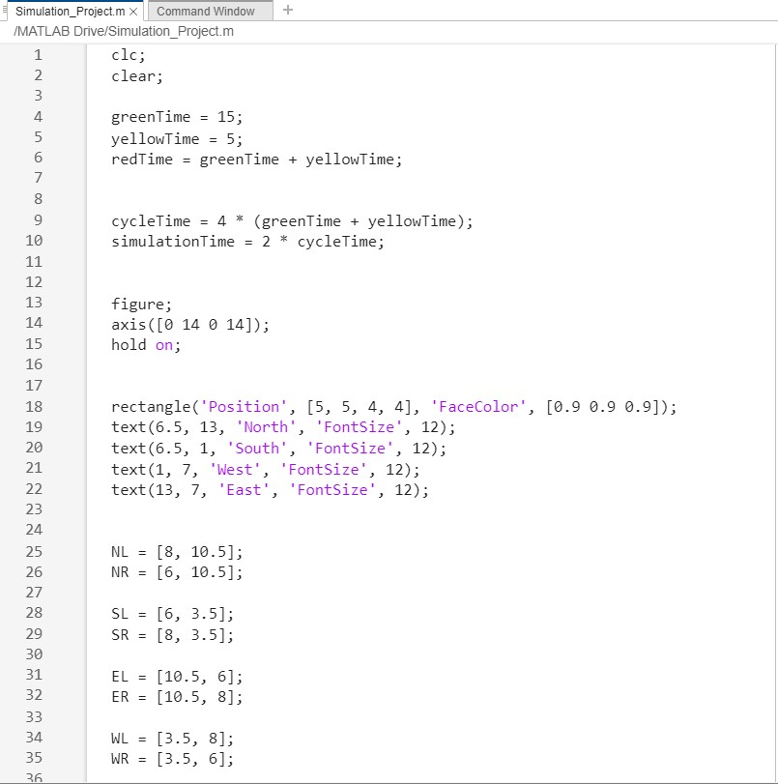

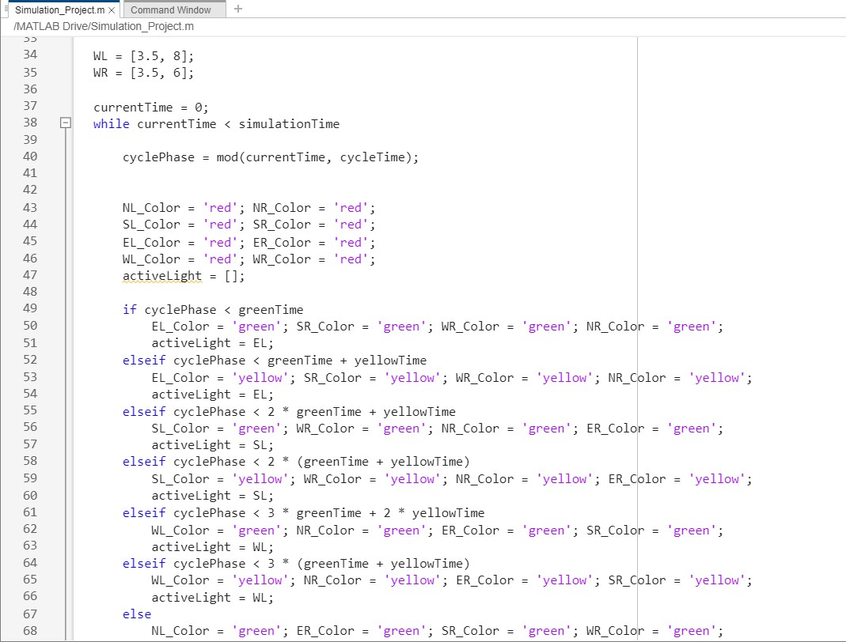

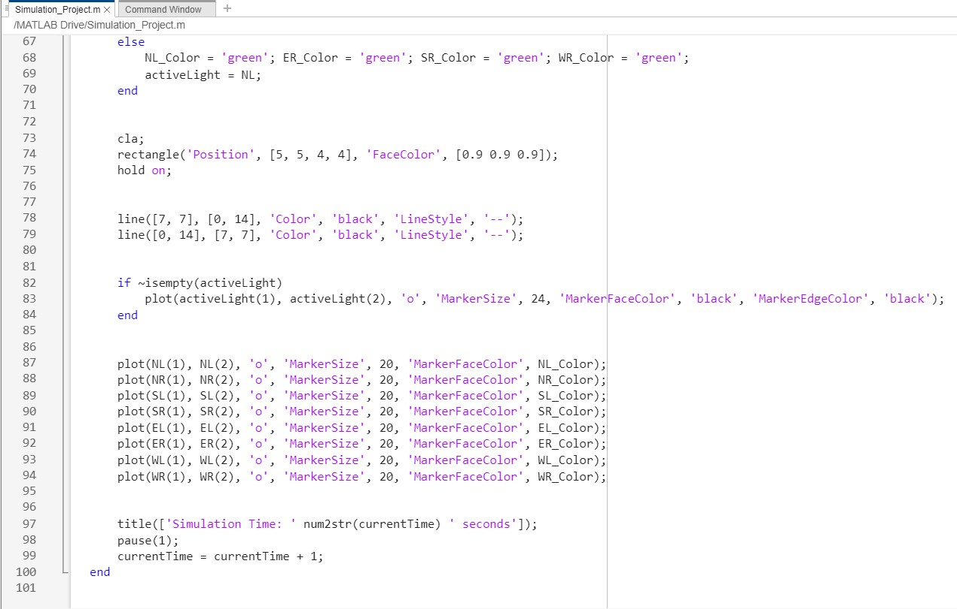

**Code Overview:**

The MATLAB code is structured to:

1. Define the timing intervals for green, yellow, and red lights.
2. Create a graphical representation of the intersection.
3. Use loops to dynamically update the traffic lights’ states based on the simulation cycle.
4. Display the active phase using visual cues like highlighted lights and markers.

The traffic light states are updated systematically to manage the flow of vehicles in all directions. Each phase ensures that vehicles from one direction move while others stop, maintaining safety and efficiency.

**Output:**

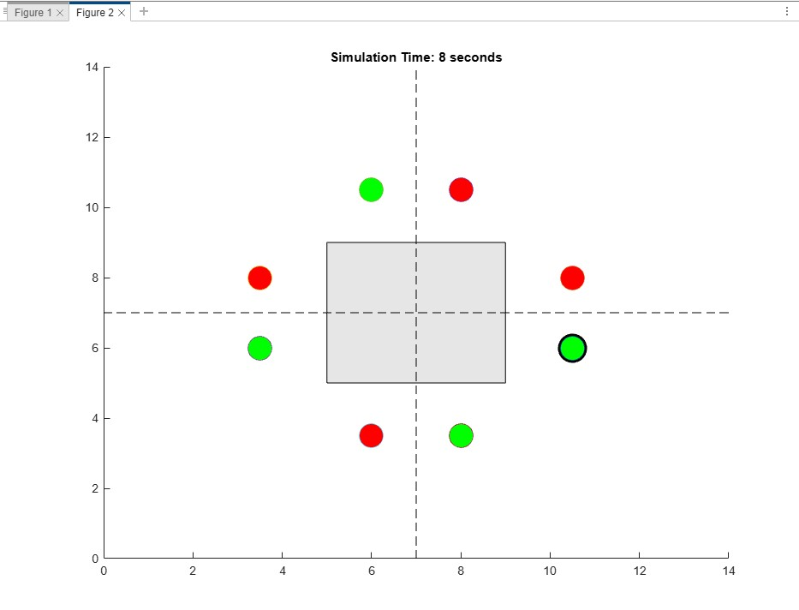

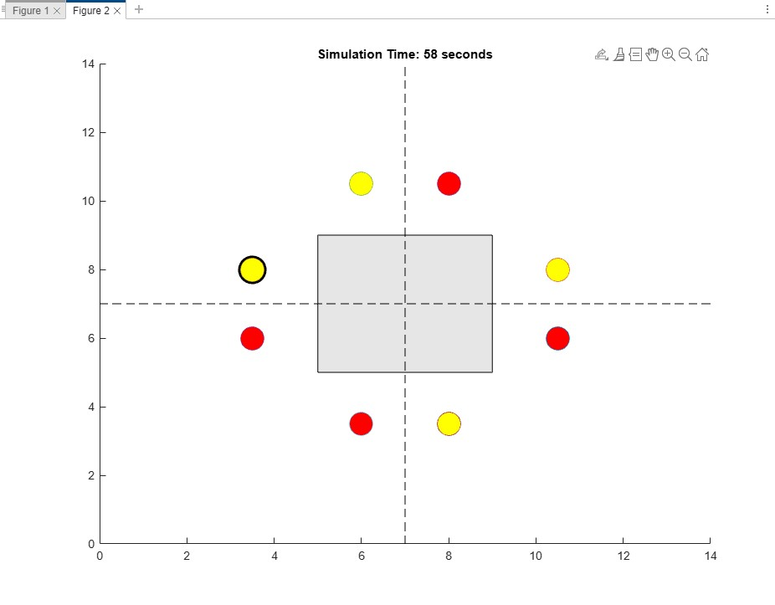

The simulation provides a clear visualization of traffic light management at a multi-lane intersection. Key outputs include:

* Real-time updates of traffic light states (green, yellow, red) for each lane.
* Graphical highlighting of active lanes during each phase.
* Smooth transitions between traffic light phases to simulate real-world traffic scenarios.

**Result:**

The "Smart Traffic Light Simulation for Multi-Lane Intersections" successfully demonstrates the management of traffic lights in a simulated environment. The system cycles through green, yellow, and red phases for different lanes, ensuring efficient and systematic traffic flow. The graphical visualization provides an intuitive understanding of traffic management, making it a valuable tool for analyzing and improving real-world traffic systems.

**Conclusion:**

In conclusion, this project highlights the potential of simulation tools in studying and improving traffic light systems. By using MATLAB for visualization and timing control, the "Smart Traffic Light Simulation for Multi-Lane Intersections" achieves a realistic representation of traffic light behavior. The project serves as a foundation for further research into intelligent traffic management systems and provides insights into optimizing traffic flow at complex intersections. With continued development, this simulation can be extended to include adaptive traffic lights that respond to real-time traffic data.

The End